**Master filter for Salesbuddy**

This SOP provides a detailed guide for users on how to apply and clear the Master Filter to obtain a filtered data view within a selected date range.

**Process Overview:**

This SOP guides users through the process of applying and clearing the Master Filter to view and analyse data within a selected date range.

* **Applying Master Filter**

**Step1: Access “Performance” section:**

- Login to the system and navigate to the “Performance” section.

**Step2: Select “All Stores” module:**

- Within the “performance” section, select “All Stores” module.

**Step3: Click on “Details view” page:**

- Click on the “Details view” page to more detailed data view & apply master filter.

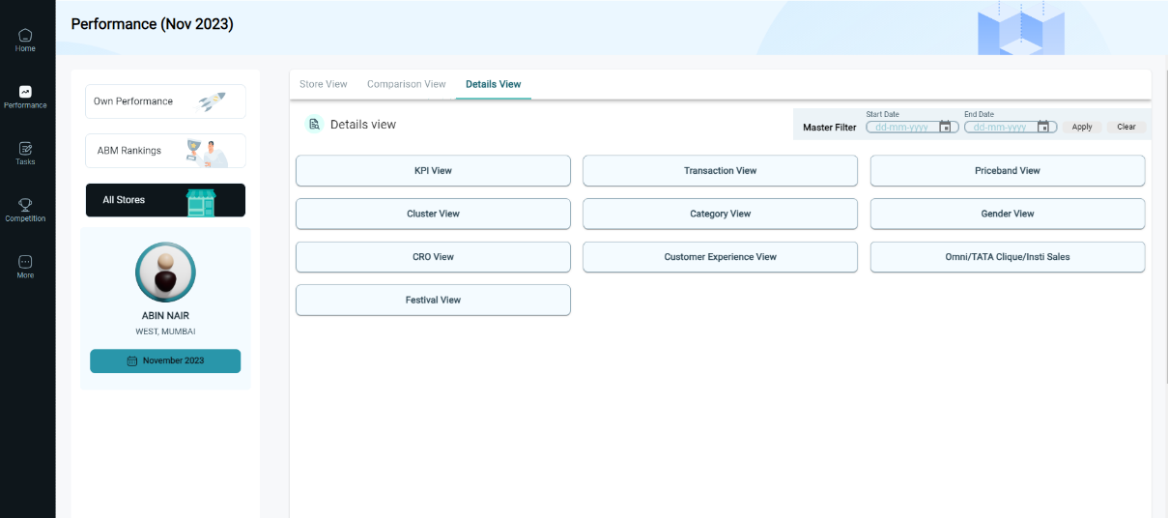

**Step4: Choose date range:**

- In the “details view” page, click on the calendar icon to open the popup calendar. Now choose a start and end date within the calendar.

Click here to select a date

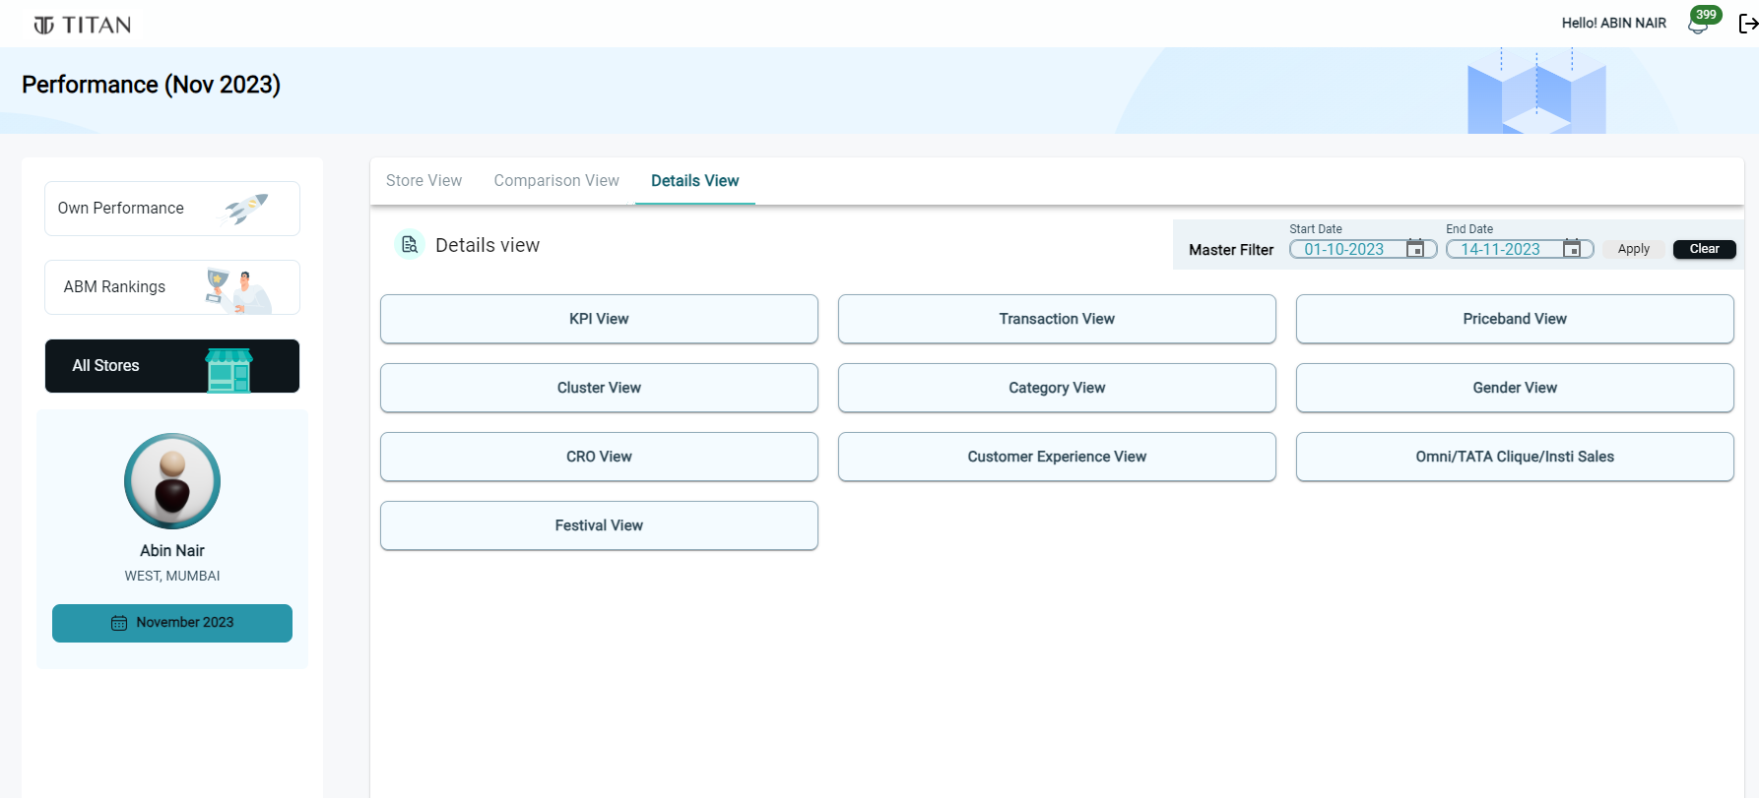

**Step5: Apply Master Filter:**

- Click on the “Apply” button. A popup will confirm that the master filter is applied. Now click on “ok” button.

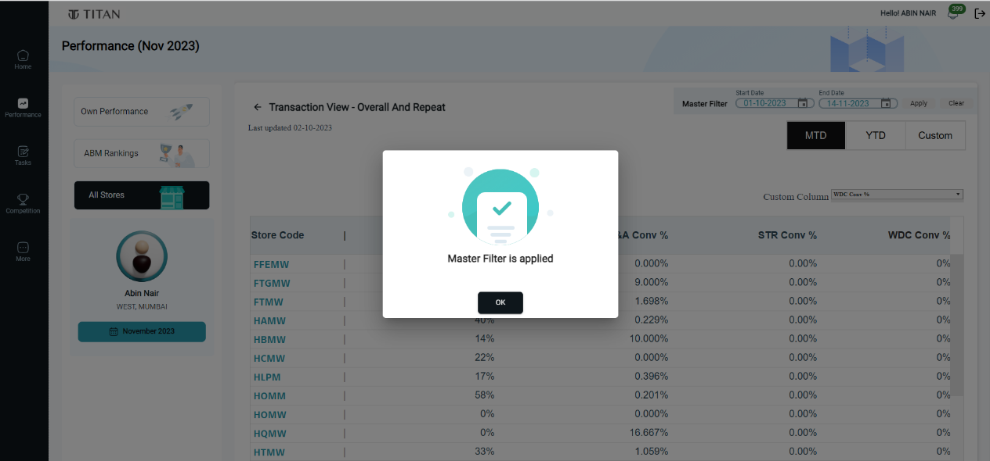

Click on OK

**Step6: View filtered data:**

- After applying the Master Filter, the filtered data will be visible in all section.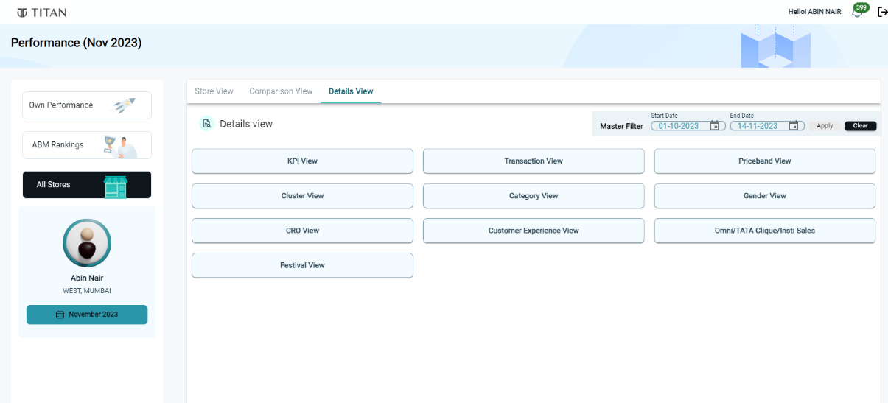

**Step7: view MTD & YTD data:**

- In addition of applying master filter, users can also view MTD & YTD data directly after applying custom filter by clicking on respective column.

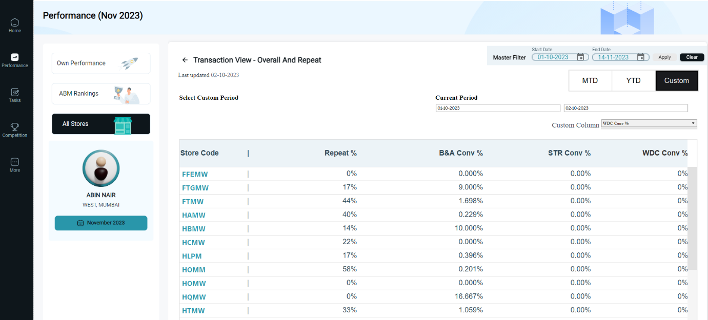

* **Clearing Master Filter:**

**Step 1: Click "Clear" button:**

- To clear the Master Filter, click on the "Clear" button.



Click here

**Step 2: Redirect to MTD Page:**

- After clicking "Clear" button, the system will automatically redirect to the MTD page.

This SOP demonstrates how the Master Filter enhances the user experience by allowing them to view filtered data within a selected date range.